Web Designing Assignment Term-1 Module (Html)-1 Name: Shruti Vishwakarma

* Question and Answer

1. Are the Html Tags and Elements the same things? No, all tags and element are not the same things in html. They are different from each other because they all tags and elements have different roll. If all the tags and elements are same so we will not get the right output.
2. What are tag and attributes in html? Tags means which hold the elements and the content what ever we write and attributes means which describe about the elements in details. or we can say that it give us the characteristic about the html element.
3. What are Void element in html? Example
4. What are Html Entities? With Example
5. What are different types of list in html? With Example There are three types of list in html they are: OL= Oder List. In Oder list small and capital letter UL= Under List . In under list there are some marks like square circle , disk, non. DL= Data List**/** Description List 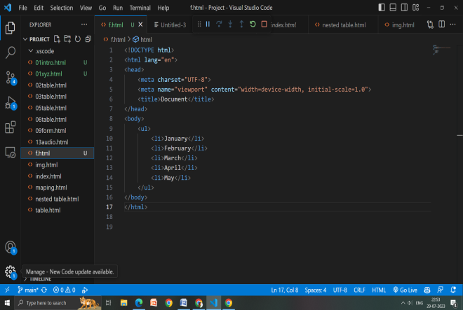 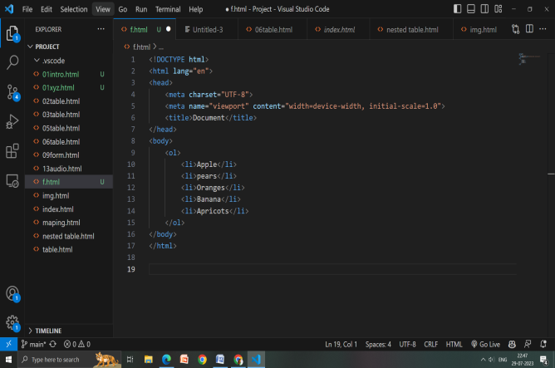 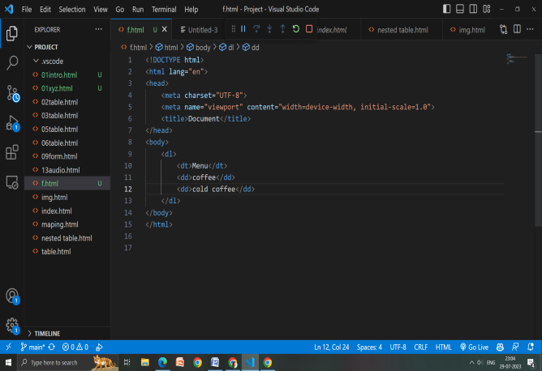
6. What is class attribute in Html? With example. Class attribute mean we can select more than one element and also we can change the style in that by using the class name for example: <h1 class= “one”>xyz</h1> <h2 class= “one”>xyz</h2> <h3 class= “one”>xyz</h3>
7. What is difference between the ‘id’ attribute and the class attribute of Html element? With example. Class attribute means that we can select one or more then classnames for an element. Id attribute which specifies a unique id for Html. class attribute can use multiple time in html but id attribute can only use for the once in html. For an example: class attribute <h1 class= “one”>xyz</h1> <h2 class= “one”>xyz</h2> <h3 class= “one”>xyz</h3> Id attribute: <h1 Id= “two”>xyz</h1>
8. What are the various formatting tags in Html? The formatting tags are for designed the various types of text. <div></div>, <br>, <b> </b>,<u></u>, <hr>,<p></p> this are the various formatting tags which are been used for designing.
9. How is cell padding is different from cell spacing? With example. Cell padding means to give the inside cell space. It define the space between cell wall and the content. Example: <table border=“1” cellpadding=“5”> Cell spacing means to give outside cell space. It define the space between each cell. Example: <table border=“1” cellspacing=“3”>
10. How we can club two or more rows and columns into a single row or columns in an html table? With example. To merge the row and columns we have to use a tag cal rowspan and colspan. Rowspan is use to merge the row. Colspan is use for columns Example: <td colspan=“2”>xyz</td> <td rowspan=“3”>xyz</td>
11. What is different between a block-level element and an inline element? An inline element does not start from new line. It only take up as much as width is required. Block level element will cover the 100% width of the page then the other part will go down .
12. How to create a Hyperlink in html? With example. To make a hyperlink in html we have to use <a>and </a> here the **ta**gs start <a> and end </a> this will create the hyperlink in html.

Example: <a href=“”></a>.

1. What is the use of an iframe tag? Explain with example Iframe tag is use to load the content from another site. Example if we want a to location then there we can use the code iframe here we have to open the location what we can and then we have to the share option and there embad a map from there we can copy the code and paste it and then run. So here we can se the location on the webpage.
2. What is the use of a span tag? Explain with example.